
Derrylatinee Saint Francis’ Primary School

Child Protection Policy

Policy Updated: February 2026
Next Review by Safeguarding Team: February 2027
Next BoG Approval: Term 2 2028

Signed:

O. Harris (Principal)

J. Goodwin (Designated Teacher)

J. Quinn (Chair of Board of Governors)

04/03/26 (Date)

Contents
- Our School’s Mission Statement Page 4
- School Policies Related to Child Protection Page 4
- The School’s Safeguarding Team Page 5
- Roles and Responsibilities of School Stakeholders Page 5
5. Definitions of Harm Page 9
6. Signs and Symptoms of Abuse Page 14
7. Responding to a Safeguarding Concern/Disclosure Page 14
8. Consent, Confidentiality, Information Sharing and Record Keeping Page 18
9. Safe Recruitment Procedures Page 19
10. Code of Conduct Paid / Unpaid Staff Page 19
11. The Preventative Curriculum Page 20
12. Operation Encompass Page 22
13. Monitoring and Evaluation Page 23
14. Appendices:
14.1 Appendix 1 Specific Types of Abuse
14.2 Appendix 2 Children with Increased Vulnerabilities
14.3 Appendix 3 How a Parent Can Make a Complaint
14.4 Appendix 4 Procedure Where the School Has Concerns about Possible Abuse
14.5 Appendix 5 Dealing with Allegations of Abuse against a Member of Staff
14.6 Appendix 6 Note of Concern Proforma
14.7 Appendix 7 Signs and Symptoms of Abuse – Possible Indicators
14.8 Appendix 8 Safeguarding Team Poster
14.9 Appendix 9 Remember the 5 R’s Poster
14.10 Appendix 10 Useful Contacts

1.Child Protection Ethos
We in Derrylatinee St. Francis’ have a responsibility for the safeguarding and child protection of the children in our care and we will carry out this duty by providing a caring, supportive and safe environment, where each child is valued for his or her unique talents and abilities, and in which all our young people can learn and develop to their full potential. All staff, teaching and non-teaching should be alert to the signs of possible abuse and should know the procedures to be followed. This Policy sets out guidance on the action, which is required where abuse or harm to a child is suspected, and outlines referral procedures within our school.

1.1 Key Principles of Safeguarding and Child Protection

The general principles, which underpin our work, are those set out in the UN Convention on the Rights of the Child and are enshrined in the Children (Northern Ireland) Order 1995, “Co-Operating to Safeguard Children and Young People in Northern Ireland” (DOH, 2017), the Department of Education (Northern Ireland) guidance “Safeguarding and Child Protection in Schools” (DENI Circular 2017/04) (amended September 2023; updated September 2024 and the Safeguarding Board for NI Core Child Protection Policy and Procedures (2017).

The following principles form the basis of our Child Protection Policy:
- The child or young person’s welfare is paramount
- The voice of the child or young person should be heard
- Parents are supported to exercise parental responsibility and families helped stay together
- Partnership
- Prevention
- Responses should be proportionate to the circumstances
- Protection and
- Evidence based and informed decision making

Adult Safeguarding
- For further information see: https://www.health-ni.gov.uk/publications/adult-safeguarding-prevention-and-protection-partnership-key-document
- Adult safeguarding is based on fundamental human rights and on respecting the rights of adults as individuals, treating all adults with dignity and respecting their right to choose. It involves empowering and enabling all adults, including those at risk of harm, to manage their own health and well-being and to keep themselves safe. It extends to intervening to protect where harm has occurred or is likely to occur and promoting access to justice. All adults at risk should be central to any actions and decisions affecting their lives.

We are committed to:
• Ensuring that the welfare of vulnerable adults is paramount at all times.
• Maximising the student’s choice, control and inclusion, and protecting their human rights.
• Working in partnership with others in order to safeguard vulnerable adults.

We will follow the procedures outlined in this policy when responding to concerns or disclosures of abuse relating to our students who are 18 years or over.

2. School Policies related to Child Protection
The school has a duty to ensure that safeguarding permeates all activities and functions. This policy therefore complements and supports a range of other school policies/regional policies and guidance including:

- Positive Behaviour Policy
- Anti-Bullying
- Staff Code of Conduct
- Use of Reasonable Force/Safe Handling
- Special Educational Needs
- Educational Visits
- First Aid and the Administration of Medicines/Drugs
- Health and Safety Policy
- Use of Video Cameras & Photographs
- ICT and Acceptable Use (e-Safety)
- Intimate Care
- Staff Welfare
- Relationships and Sexuality Education
- Teaching and Learning
- Attendance

These policies are available to parents and any parent who wishes to obtain a copy should contact the School Principal. A full list of policies is available on the Parents’ section of our website. (www.derrylatineeps.co.uk )

3. School Safeguarding Team

The following are members of the school’s Safeguarding Team:
- Chair of the Board of Governors – Dr Justin Quinn
- Designated Governor for Child Protection – Mr Phelim Marrion
- Principal – Mrs Orla Harris
- Designated Teacher – Mrs Joanne Goodwin
- Deputy Designated Teacher – Mrs Áine Conlan

Safeguarading Team posters are displayed in every classroom, on the Child Protection Noticeboard, throughout the whole school and on the school website. See Appendix 9

4. Roles and Responsibilities of School Stakeholders

4.1 Chair of the Board Of Governors
The Chair of the Board of Governors must:
- Ensure that a safeguarding ethos is maintained within the school environment;
- Ensure that the school has a Child Protection Policy in place and that staff implement the policy;
- Ensure that Governors undertake appropriate child protection and recruitment & selection training provided by the EA Child Protection Support Service for Schools, the EA Schools Development Service and Human Resource departments;
- Ensure that a Designated Governor for Child Protection is appointed;
- Assume lead responsibility for managing any complaint/allegation against the School Principal;
- Ensure that the Board of Governors receive updates at each Board of Governors meeting and a full written annual report in relation to Safeguarding activity.

4.2 The Designated Governor for Child Protection

The Designated Governor will provide the child protection lead in order to advise the Governors on:
- The role of the designated teachers
- The content of child protection policies
- The content of a code of conduct for adults within the school
- The content of the updates at each Board of Governors’ meeting and full Annual Designated Teachers Report
- Recruitment, selection and vetting of staff.

4.3 The Board of Governors
The Board of Governors as a body must ensure that the school fulfils its safeguarding responsibilities in keeping with current legislation and DE guidance including:
- To ensure the school has a Safeguarding and Child Protection Policy in place and that staff implement the policy;
- Relevant Child Protection training is kept up-to-date and a record kept of the same;
- That confidentiality is paramount. Information should only be passed to members of the Board of Governors on a need-to-know basis;
- Ensuring that safeguarding/child protection is a standard item on the agenda of Board of Governor meetings;
- Approving the schools safeguarding and child protection policy at least once every 2 years;
- Ensuring that there is a time-tabled review (every 2/3 years) of all other safeguarding policies and that they are presented to the BOG for approval;
- Receiving annual safeguarding reports;
- Ensuring there is a staff code of conduct for all adults working in the school.

4.4 Responsibilities of the Principal

The Principal must ensure that:
- DENI 2017/04 is implemented within the school;
- That a designated teacher and deputy are appointed;
- That all staff receive training;
- That all necessary referrals are taken forward in the appropriate manner;
- That complaints or allegations against school staff are appropriately managed;
- That the Chairman of the Board of Governors (and the Board of Governors) is kept informed;
- That the EA Designated Officer for Child Protection are consulted as appropriate;
- That a record of Child Abuse Complaints is maintained and made available at least annually to the Board of Governors;
- That the school’s child protection records are securely stored and maintained in accordance with DENI circular 2016/20;
- That Safeguarding activities feature on the agenda of the Board of Governors meetings;
- That the school child protection policy is reviewed annually and that parents and pupils receive a summary of this policy at least once every 2 years;
- That confidentiality is paramount, information should only be passed to the Board of Governors on a need to know basis;
- That the Chairman of the Board of Governors and the Board of Governors are kept appropriately informed.

4.5 Responsibilities of Designated Teacher (and Deputy)

The designated teacher and deputy must

- Avail of training so that she is aware of duties, responsibilities and role;
- Assist in the drawing up of the Safeguarding and Child Protection policy;
- Disseminate the Safeguarding and Child Protection policy and update when required;
- Ensure that the policy is adhered to;
- Organise training for all staff to be delivered a minimum of once every 2 years;
- Act as a point of contact for staff (and parents);
- Assist in the drafting and issuing of the summary of our child protection arrangements for parents;
- Make referrals to Social Services (Gateway team) or PSNI Public Protection Unit where appropriate;
- Liaise with the EA’s designated officers for Child Protection;
- Maintain records of all child protection concerns;
- Keep the School Principal informed;
- Provide written annual report to the Board of Governors regarding safeguarding.

4.6 The Class Teacher

Teachers see children over long periods and can notice physical, behavioural and emotional indicators and hear allegations of abuse.

The teacher must:
- Listen to what is being said and support the child;
- Make a concise written record of a child’s disclosure using the actual words of the child (appendix 5a);
- Keep the Designated Teacher informed through the written “Note of Concern” pro-forma (appendix 2) or verbally about poor attendance and punctuality, poor presentation, changed or unusual behaviour, deterioration in educational progress, discussions with parents about concerns relating to their child, concerns about pupil abuse or serious bullying, concerns about home conditions;
- Avail of whole school training and relevant other training regarding safeguarding children;
- Act promptly.

4.7 Support Staff

If any member of the support staff in our school has concerns about a child or staff member they should report these concerns to the Designated Teacher or Deputy Designated Teacher if she is not available. A detailed written record of the concerns will be made and any further necessary action will be taken.

4.8 The Parents

Parents should play their part in Child Protection by:

- Telephoning the school on the morning of their child’s absence, or sending in a note on the child’s return to school, so as the school is reassured as to the child’s situation;
- Informing the school whenever anyone, other than themselves, intends to pick up the child after school;
- Providing the school with written evidence i.e. a Court Order to support any request to the Principal for changes to arrangements for contact with their child;
- Informing the school of any changes of address, contact details or living arrangements for their child e.g. child going to live with a relative;
- Familiarising themselves with the School’s Pastoral Care, Anti Bullying, Positive Behaviour, Internet and Child Protection Policies;
- Reporting to the office when they visit the school;
- Raising any concerns they have in relation to their child with the school.

Child Protection Definitions

5. Definition of Harm

Harm can be suffered by a child or young person by acts of abuse perpetrated upon them by others. Abuse can happen in any family, but children may be more at risk if their parents have problems with drugs, alcohol and mental health, or if they live in a home where domestic abuse happens. Abuse can also occur outside of the family environment. Evidence shows that babies and children with disabilities can be more vulnerable to suffering abuse.
Although the harm from the abuse might take a long time to be recognisable in the child or young person, professionals may be in a position to observe its indicators earlier, for example, in the way that a parent interacts with their child. Effective and ongoing information sharing is key between professionals.

Harm from abuse is not always straightforward to identify and a child or young person may experience more than one type of harm.

5.1 Harm can be caused by:
- Sexual abuse
- Emotional abuse
- Physical abuse
- Neglect
- Exploitation

Sexual Abuse occurs when others use and exploit children sexually for their own gratification or gain or the gratification of others. Sexual abuse may involve physical contact, including assault by penetration (for example, rape, or oral sex) or non-penetrative acts such as masturbation, kissing, rubbing and touching outside clothing. It may include non-contact activities, such as involving children in the production of sexual images, forcing children to look at sexual images or watch sexual activities, encouraging children to behave in sexually inappropriate ways or grooming a child in preparation for abuse (including via e-technology). Sexual abuse is not solely perpetrated by adult males. Women can commit acts of sexual abuse, as can other children.

Emotional Abuse is the persistent emotional maltreatment of a child. It is also sometimes called psychological abuse and it can have severe and persistent adverse effects on a child’s emotional development.

Emotional abuse may involve deliberately telling a child that they are worthless, or unloved and inadequate. It may include not giving a child opportunities to express their views, deliberately silencing them, or ‘making fun’ of what they say or how they communicate. Emotional abuse may involve bullying – including online bullying through social networks, online games or mobile phones – by a child’s peers.

Physical Abuse is deliberately physically hurting a child. It might take a variety of different forms, including hitting, biting, pinching, shaking, throwing, poisoning, burning or scalding, drowning or suffocating a child.

Neglect is the failure to provide for a child’s basic needs, whether it be adequate food, clothing, hygiene, supervision or shelter that is likely to result in the serious impairment of a child’s health or development. Children who are neglected often also suffer from other types of abuse.

Exploitation is the intentional ill-treatment, manipulation or abuse of power and control over a child or young person; to take selfish or unfair advantage of a child or young person or situation, for personal gain. It may manifest itself in many forms such as child labour, slavery, servitude, and engagement in criminal activity, begging, benefit or other financial fraud or child trafficking. It extends to the recruitment, transportation, transfer, harbouring or receipt of children for the purpose of exploitation. Exploitation can be sexual in nature.
Although ‘exploitation’ is not included in the categories of registration for the Child Protection Register, professionals should recognise that the abuse resulting from or caused by the exploitation of children and young people can be categorised within the existing CPR categories as children who have been exploited will have suffered from physical abuse, neglect, emotional abuse, sexual abuse or a combination of these forms of abuse.

5.2 Signs and Symptoms of Abuse – See Apendix 7
Appendix 7 provides a comprehensive breakdown of the physical and behavioural indicators for Physical Abuse, Neglect, Emotional Abuse and Sexual Abuse.

Specific Types of Abuse
In addition to the types of abuse described above there are also some specific types of abuse that we in Derrylatinee St. Francis’ are aware of and have therefore included them in our policy. Please see these in Appendix 1.
Adult Safeguarding
An ‘Adult at risk of harm’ is a person aged 18 or over, whose exposure to harm through abuse, exploitation or neglect may be increased by their:
a) Personal characteristics and/or
b) Life circumstances
Personal characteristics may include, but are not limited to, age, disability, special educational needs, illness, mental or physical frailty or impairment of, or disturbance in, the functioning of the mind or brain.
Life circumstances may include, but are not limited to, isolation, socio-economic factors and environmental living conditions.
An ‘Adult in need of protection’ is a person aged 18 or over, whose exposure to harm through abuse, exploitation or neglect may be increased by their:
a) Personal characteristics and/or
b) Life circumstances and
c) Who is unable to protect their own well-being, property, assets, rights or other interests; and
d) Where the action or inaction of another person or persons is causing, or is likely to cause, him/her to be harmed.

Children with Increased Vulnerabilities

Some children have increased risk of abuse due to specific vulnerabilities such as disability, lack of fluency in English and sexual orientation. We have included information about children with increased vulnerabilities in our policy. Please see these in Appendix 2.

5.3 Child Protection and Harm in Other Specific Circumstances

Bullying
The damage inflicted by bullying can frequently be underestimated. It can cause considerable distress to children and at the extreme cause them significant harm (including self-harm). The procedure for referral and investigation of abuse may therefore be implemented in certain circumstances such as:

- Anti-bullying procedures have failed to be effective;
- Bullying is persistent and severe, resulting in the person experiencing bullying type behaviour suffering/likely to suffer significant harm;
- There are concerns that the bullying behaviour is indicative of the person displaying bullying type behaviour suffering/likely to suffer significant harm;
- Where concerns exist in relation to the parents/carer’s capacity to meet the needs of the child (either the person experiencing or the person displaying bullying type behaviour).

In accordance with the procedure, the needs of the person experiencing the bullying type behaviour and the person displaying bullying type behaviour will be considered separately taking into account the family situation and the wider community.
The school has a detailed anti-bullying policy which can be obtained from the school.

E-Safety
In Derrylatinee St. Francis’ we understand the responsibility to educate our pupils in e-Safety issues. We aim to teach appropriate behaviours and critical thinking to enable them to remain both safe and legal when using the internet and related technologies, in and beyond the context of the classroom.
As e-Safety is an important aspect of strategic leadership within the school, Mrs. Harris, the Principal, and the Board of Governors have ultimate responsibility to ensure that the policy and practices are embedded and monitored. It is the role of the ICT Co-ordinator to keep abreast of current e-safety issues and guidance through organisations such as CEOP (Child Exploitation and Online Protection) and Childnet. The ICT co-ordinator (Mr. Canavan) has responsibility for leading and monitoring the implementation of e-safety throughout the school in consultation with the principal.

Children Who Sexually Abuse Others or Display Sexually Harmful Behaviour

When abuse of a child is alleged to have been carried out by another child, the procedures are outlined below. It is important in such situations to distinguish between behaviours which are experimental in nature and those that are exploitative and harmful. Advice and support will be sought in such circumstances from an EA Designated Officer for Child Protection and where appropriate a referral made to the statutory agencies. In all such cases a risk assessment will be considered and a risk management / pupil support plan identified in line with DENI circular 2016/05.

Child Sexual Exploitation

Child sexual exploitation is a form of child sexual abuse. It occurs where an individual or group takes advantage of an imbalance of power to coerce, manipulate or deceive a child or young person under the age of 18 into sexual activity (a) in exchange for something the victim needs or wants, and/ or (b) for the financial advantage or increased status of the perpetrator or facilitator. The victim may have been sexually exploited even if the sexual activity appears consensual. Child sexual exploitation does not always involve physical contact; it can also occur through the use of technology.

Sexual exploitation can range from opportunistic exploitation to more calculated, progressive and protracted exploitative behaviours. Abusers are often skilled in manipulating and exploiting young people, using affection, attention, treats, alcohol, drugs or just a place to ‘hang out’ or stay to gain and abuse a young person’s trust; sometimes they may manipulate the young person into believing they are in an affectionate and consensual relationship. Frequently alcohol and drugs are provided to intoxicate and immobilise victims, making them more vulnerable to abuse. Alcohol and drugs are also used to create dependence and the perpetrators’ control over victims. Frequently victims are subject to intimidation, threat and actual violence and/or threats or actual violence against their family or others they care about. Whatever the method of exploitation, the young person is being taken advantage of, exploited and abused through this controlling behaviour.
(Cooperating to safeguard children and young people in Northern Ireland 2017)

Any child under the age of eighteen, male or female, can be a victim of CSE, including those who can legally consent to have sex. The abuse most frequently impacts upon those of a post-primary age and can be perpetrated by adults or peers, on an individual or group basis.

The potential indicators of CSE can include, but are not limited to:

• Acquisition of money, clothes, mobile phone etc. without plausible explanation;
• Leaving home/care without permission;
• Persistently going missing or returning late;
• Receiving lots of texts/phone calls prior to leaving;
• Agitated/stressed prior to leaving home/care;
• Returning distraught/ dishevelled or under the influence of substances;
• Requesting the morning after pill upon return;
• Truanting from school;
• Inappropriate sexualised behaviour for age;
• Physical symptoms or infections e.g. bruising, bite marks, sexually transmitted infections;
• Concerning use of the internet;
• Entering or leaving cars driven by unknown adults or by taxis;
• New peer groups;
• Significantly older ‘boyfriend’ or ‘girlfriend’;
• Increasing secretiveness around behaviours;
• Low self-esteem;
• Change in personal hygiene (greater attention or less);
• Self harm and other expressions of despair;
• Evidence or suspicion of substance misuse.

Whilst these indicators can be usefully used to identify potential risk, it is important to note that their presence does not necessarily mean that CSE is occurring. More importantly, nor does their absence, mean that it is not.

Indecent Photographs
The offence of taking indecent pictures of children under 18 years can apply in a situation where a pupil has taken an indecent picture using a mobile phone of others under 18 years of age. It is also an offence to distribute, possess with intent to distribute or show such photographs to others. In such circumstances the PSNI will be contacted.

6. Signs and Symptoms of Abuse (these are outlined in Appendix 1).

7. Responding to a Safeguarding Concern/Disclosure

The following are guidelines for use by staff should a child disclose concerns of a child protection nature. The 5 R’s posters are displayed in each class and in central areas throughout the school. A copy is included in Appendix 8.

Receive – listen to what the child says, without displaying shock or disbelief. Accept what is said, making brief cursory notes. These notes should be retained.

Reassure- ensure the child is reassured that he/she will be safe and his/her interests will come first. No promise of confidentiality can or should be made to a child or anyone else giving information about possible abuse.

Respond- respond to the child only as far as is necessary for you to establish whether or not you need to refer the matter. Use open questions e.g. anything else to tell me? Do not interrogate or ask leading questions- this may invalidate your evidence and the child’s in any later court proceedings. Do not criticise the perpetrator- the child may love this person and reconciliation may be possible. Explain what you have to do next and to whom you have to talk.

Record- make notes at the time and write these up as soon as possible afterwards. Note the time, date, place, people present as well as what is seen and said. Record key phrases/words used, noticeable non-verbal behaviour and any physical injuries. Under no circumstances should a child be photographed or a child’s clothing removed. Do not destroy original notes.

Report- refer the matter to the Designated Teacher. Respect confidentiality i.e. the matter should only be discussed on a need to know basis.

7.1 Responding to Safeguarding and Child Protection Concerns

Safeguarding is more than child protection. Safeguarding begins with promotion and preventative activity which enables children and young people to grow up safely and securely in circumstances where their development and wellbeing is not adversely affected. It includes support to families and early intervention to meet the needs of children and continues through to child protection. Child protection refers specifically to the activity that is undertaken to protect individual children or young people who are suffering, or are likely to suffer significant harm.

How a parent can raise a concern
In Derrylatinee St. Francis’ we aim to work closely with parents/guardians in supporting all aspects of their child’s development and well-being. Any concerns a parent may have will be taken seriously and dealt with in a professional manner.
If a parent has a concern they can talk to the class teacher or the Principal, Mrs. Harris, the Designated Teacher for child protection, Mrs. Goodwin, or the Deputy Designated Teacher for child protection, Mrs. Conlan.
If they are still concerned they may talk to the Chair of the Board of Governors (Dr. Justin Quinn). If after this a parent still has concerns they can contact the NI Public Services Ombudsman.
At any time a parent may talk to a social worker in the local Gateway team or to the PSNI Central Referral Unit. Details of who to contact are shown in the flowchart in Appendix 3.

7.2 Where school has concerns or has been given information about possible abuse by someone other than a member of staff
In Derrylatinee St. Francis’ if a child makes a disclosure to a teacher or other member of staff which gives rise to concerns about possible abuse, or if a member of staff has concerns about a child, the member of staff will complete a Note of Concern (see Appendix 6) and act promptly. Notes of concern are available from our Child Protection notice boards or the school Principal or the Designated Teacher. They will not investigate - this is a matter for Social Services - but will discuss these concerns with the Designated Teacher or with the Deputy Designated Teacher if she is not available.
The Designated Teacher will consult with the Principal or other relevant staff always taking care to avoid due delay. If the Principal is unavailable the Designated Teacher will contact the Designated Governor whose contact details are avbailable in the Board of Governor file. If required, advice may be sought from an Education Authority Child Protection Officer. The Designated Teacher may also seek clarification from the child or young person, their parent/carer.
If a child protection referral is not required the school may consider other options including monitoring, signposting or referring to other support agencies e.g. Family Support Hub with parental consent and, where appropriate, with the child/young person’s consent.

If a child protection referral is required the Designated Teacher will seek consent from the parent/carer and/or the child {if they are competent to give this} unless this would place the child at risk of significant harm.

The Designated Teacher will phone the Gateway team and/or the PSNI and will submit a completed UNOCINI referral form. Where appropriate, the source of the concern will be informed of the action taken.

For further detail please see Appendix 4.

The following are basic guidelines for use by staff should a child disclose concerns of a child protection nature:

Do’s | Don’ts
- Stay calm  - Listen  - Accept  - Reassure  - Explain what you are going to do  - Record accurately  - Seek support for yourself | - Panic/ Promise to keep secrets  - Ask leading questions  - Make the child repeat the story unnecessarily  - Delay  - Start to investigate  - Do nothing

7.3 Where a complaint has been made about possible abuse by a member of the school’s staff or a Volunteer

When a complaint about possible child abuse is made against a member of staff the Principal (or the Designated Teacher if the Principal is not available) must be informed immediately. If the complaint is against the Principal then the Designated Teacher should be informed and she will inform the Chairperson of the Board of Governors who will consider what action is required in consultation with the employing authority. The procedure as outlined in Appendix 5 will be followed.

8. Consent

Concerns about the safety or welfare of a child/young person, should, where practicable, be discussed with the parent and consent sought for a referral to children's social services in the local HSC Trust, unless seeking agreement is likely to place the child/young person at further risk through delay or undermine any criminal investigative process (for example in circumstances where there are concerns or suspicions that a crime has taken place); or there is concern raised about the parent's actions or reactions. The communication/language needs of the parents/carers should be established for example in relation to disability/ethnicity and the parent's/carer's capacity to understand should be ascertained. These should be addressed through the provision of appropriate communication methods, including, where necessary, translators, signers, intermediaries or advocacy services.
Effective protection for children/young people may, on occasions, require the sharing of information without prior parental/carer consent in advance of that information being shared.
Where staff decide not to seek parental consent before making a referral to children's social services in the local Health and Social Care Trust or the police, the reason for this decision must be clearly noted in the child/young person's records and included within the verbal and written/UNOCINI referral.
When a referral is deemed to be necessary in the interests of the child/young person, and the parents/carers have been consulted and do not consent, the following action should be taken:
- The reason for proceeding without parental consent must be recorded;
- The withholding of permission by the parent/carer must be included in the verbal and written referral to children's social services;
- The parent/carer should be contacted to inform them that, after considering their wishes, a referral has been made.
Staff making a referral may ask for their anonymity to be protected as far as possible because of a genuine threat to self/family. In such instances this anonymity should be protected with an explanation to the staff member that absolute confidentiality cannot be guaranteed as information may become the subject of court processes.

8.1 Confidentiality and Information Sharing

Information given to members of staff about possible child abuse cannot be held “in confidence”. In the interests of the child, staff have a responsibility to share relevant information about the protection of children with other professionals particularly the investigative agencies. In keeping with the principle of confidentiality, the sharing of information with school staff will be on a ‘need to know’ basis.
Where there have been, or are current, child protection concerns about a pupil who transfers to another school we will consider what information should be shared with the Designated Teacher in the receiving school.
Where it is necessary to safeguard children information will be shared with other statutory agencies in accordance with the requirements of this policy, the school data protection policy and the General Data Protection Regulations (GDPR).

8.2 Record Keeping

In accordance with DE guidance we must consider and develop clear guidelines for the recording, storage, retention and destruction of both manual and electronic records where they relate to child protection concerns.

In order to meet these requirements all child protection records, information and confidential notes concerning pupils in Derrylatinee St. Francis’ are stored securely in the Child Protection and Safeguarding filing cabinet in the Principal’s office. Only the Designated Teacher/Deputy Designated Teacher and Principal have access to them. In accordance with DE guidance on the disposal of child protection records these records will be stored from child’s date of birth plus 30 years. If information is held electronically, whether on a laptop or on a portable memory device, all must be encrypted and appropriately password protected.

These notes or records should be factual, objective and include what was seen, said, heard or reported. They should include details of the place and time and who was present and should be given to the Designated/Deputy Designated Teacher. The person who reports the incident must treat the matter in confidence.
9. Safe Recruitment Procedures

Vetting checks are a key preventative measure in preventing unsuitable individuals’ access to children and vulnerable adults through the education system and schools must ensure that all persons on school property are vetted, inducted and supervised as appropriate. All staff paid or unpaid who are appointed to positions in Derrylatinee St. Francis’ are vetted / supervised in accordance with relevant legislation and Departmental guidance. Appropriate Access NI details are kept in the Safeguarding Evidence file in the Principal’s office.

10. Code of Conduct for all Staff - Paid or Unpaid

All actions concerning children and young people must uphold the best interests of the young person as a primary consideration. Staff must always be mindful of the fact that they hold a position of trust and that their behaviour towards the child and young people in their charge must be above reproach. All members of staff are expected to comply with the school’s Code of Conduct for Employees and Volunteers which has been approved by the Board of Governors. (Our Staff Code of Conduct is available on request).

11. The Preventative Curriculum
The statutory personal development curriculum requires schools to give specific attention to pupils’ emotional wellbeing, health and safety, relationships, and the development of a moral thinking and value system. The curriculum also offers a medium to explore sensitive issues with children and young people in an age-appropriate way which helps them to develop appropriate protective behaviours. (DENI 2017/04)

The whole school community including teachers, support staff and parents are engaged in teaching ‘keeping safe’ messages through a preventative curriculum. Regular Circle Time sessions are used as a means of encouraging children to raise social and emotional concerns in a safe environment and to build self-confidence, respect and sensitivity among classmates.

Throughout the school year, safeguarding and child protection issues are addressed through assemblies. Safeguarding and Child Protection related posters providing advice and display child helpline numbers, are displayed in each classroom and in prominent positions around the school. Examples of some other initiatives addressing safeguarding, child protection and safety issues include:

- The NSPCC visits the school (or online) and provides information on a range of child protection issues through Assemblies, talks, role-plays, puppet shows and resources;

- Children have opportunities to participate in any available community awareness programmes that run throughout the year and facilitated by the PSNI;

- Primary 5 pupils may take part in the Northern Ireland Fire and Rescue Service talks on Fire Safety;

- NI Chest, Heart and Stroke Charity may visit the P4/5 and P7 class to deliver the healthy eating Chester Challenge programme;

- Internet safety information is provided for pupils and parents and our digital leaders ensure the message is clear and visible. REIM regularly visit and deliver internet safety workshops with children, parents and staff;

- Personal Safety/Keep Safe activities delivered at various Key Stages within the NI Curriculum under PDMU.

SCHOOL PROGRAMMES
This policy also applies to the pupils and staff engaged in After School or Shared Education Activities.

12. Operation Encompass
We are an Operation Encompass school. Operation Encompass is an early intervention partnership between local Police and our school, aimed at supporting children who are victims of domestic violence and abuse. As a school, we recognise that children’s exposure to domestic violence is a traumatic event for them.
Children experiencing domestic abuse are negatively impacted by this exposure. Domestic abuse has been identified as an Adverse Childhood Experience and can lead to emotional, physical and psychological harm. Operation Encompass aims to mitigate this harm by enabling the provision of immediate support. This rapid provision of support within the school environment means children are better safeguarded against the short, medium and long-term effects of domestic abuse.
As an Operation Encompass school, when the police have attended a domestic incident and one of our pupils is present, they will make contact with the school at the start of the next working day to share this information with a member of the school safeguarding team. This will allow the school safeguarding team to provide immediate emotional support to this child as well as giving the designated teacher greater insight into any wider safeguarding concerns.
This information will be treated in strict confidence, like any other category of child protection information. It will be processed as per DE Circular 2020/07 ‘Child Protection Record Keeping in Schools’ and a note will be made in the child’s child protection file. The information received on an Operation Encompass call from the Police will only be shared outside of the safeguarding team on a proportionate and need to know basis. All members of the safeguarding team will complete online Operation Encompass training, so they are able to take these calls. Any staff responsible for answering the phone at school will be made aware of Operation Encompass and the need to pass these calls on with urgency to a member of the Safeguarding team.
Further information see The Domestic Abuse Information Sharing with Schools etc. Regulations (Northern Ireland) 2022.

12. Monitoring and evaluation
This policy will be reviewed annually by the Safeguarding Team and approved every 2 years by the Board of Governors for dissemination to parents, pupils and staff. It will be implemented through the schools staff induction and training programme and as part of day to day practice. Compliance with the policy will be monitored on an on-going basis by the Designated Teacher for Child Protection and periodically by the Schools Safeguarding Team. The Board of Governors will also monitor child protection activity and the implementation of the Safeguarding and Child Protection policy on a regular basis through the provision of reports from the Designated Teacher.

14. Appendix 1

Specific Types of Abuse

Grooming of a child or young person is always abusive and/or exploitative. It often involves perpetrator(s) gaining the trust of the child or young person or, in some cases, the trust of the family, friends or community, and/or making an emotional connection with the victim in order to facilitate abuse before the abuse begins. This may involve providing money, gifts, drugs and/or alcohol or more basic needs such as food, accommodation or clothing to develop the child’s/young person’s loyalty to and dependence upon the person(s) doing the grooming. The person(s) carrying out the abuse may differ from those involved in grooming which led to it, although this is not always the case. Grooming is often associated with Child Sexual Exploitation (CSE) but can be a precursor to other forms of abuse. Grooming may occur face to face, online and/or through social media, the latter making it more difficult to detect and identify.
If the staff in Derrylatinee St. Francis’ become aware of signs that may indicate grooming they will take early action and follow the school’s child protection policies and procedures.

Child sexual exploitation (CSE) is a form of child sexual abuse. It occurs where an individual or group takes advantage of an imbalance of power to coerce, manipulate or deceive a child or young person under the age of 18 into sexual activity (a) in exchange for something the victim needs or wants, and/ or (b) for the financial advantage or increased status of the perpetrator or facilitator. The victim may have been sexually exploited even if the sexual activity appears consensual. Child sexual exploitation does not always involve physical contact; it can also occur through the use of technology. (Co-operating to Safeguard Children and Young People in NI. DHSSPS version 2.0 2017)
The key factor that distinguishes cases of CSE from other forms of child sexual abuse is the concept of exchange – the fact that someone coerces or manipulates a child into engaging in sexual activity in return for something they need or desire and/or for the gain of those perpetrating or facilitating the abuse. The something received by the child or young person can include both tangible items and/or more intangible ‘rewards’ OR ‘benefits’ such as perceived affection, protection or a sense of value or belonging.
Any child under the age of eighteen, male or female, can be a victim of CSE, including those who can legally consent to have sex. The abuse most frequently impacts upon those of a post-primary age and can be perpetrated by adults or peers, on an individual or group basis.
CSE is a form of child abuse and, as such, any member of staff suspecting that CSE is occurring will follow the school’s child protection policy and procedures, including reporting to the appropriate agencies.

Domestic and Sexual violence and abuse can have a profoundly negative effect on a child’s emotional, psychological and social well-being. A child does not have to witness domestic violence to be adversely affected by it. Living in a violent or abusive domestic environment is harmful to children.
Domestic violence and abuse is defined as ‘threatening, controlling, coercive behaviour, violence or abuse (psychological, virtual, physical, verbal, sexual, financial or emotional) inflicted on anyone (irrespective of age, ethnicity, religion, gender, identity, sexual orientation or any form of disability) by a current or former intimate partner or family member.’ Sexual Violence and Abuse is defined as ‘any behaviour (physical, psychological, verbal, virtual /online perceived to be of a sexual nature which is controlling, coercive, exploitative, harmful or unwanted that is inflicted on anyone (irrespective of age, ethnicity, religion, gender, gender identity, sexual orientation or any form of disability).’ (Stopping Domestic and Sexual Violence and Abuse in Northern Ireland A Seven Year Strategy: March 2016).
If it comes to the attention of school staff that Domestic Abuse, is or may be, affecting a child this will be passed on to the Designated/Deputy Designated Teacher who has an obligation to share the information with the Social Services Gateway Team.

Female Genital Mutilation (FGM) is a form of child abuse and violence against women and girls. FGM comprises all procedures that involve partial or total removal of the external female genitalia, or other injury to the female genital organs for non-medical reasons. The procedure is also referred to as ‘cutting’, ‘female circumcision’ and ‘initiation’. The practice is medically unnecessary, extremely painful and has serious health consequences, both at the time when the mutilation is carried out and in later life. FGM is a form of child abuse and, as such, teachers have a statutory duty to report cases, including suspicion, to the appropriate agencies, through agreed established procedures set out in our school policy.

Forced Marriage A forced marriage is a marriage conducted without the valid consent of one or both parties and where duress is a factor. Duress can include physical, psychological, financial, sexual and emotional pressure. Forced marriage is a criminal offence in Northern Ireland and if in Derrylatinee St. Francis’ we have knowledge or suspicion of a forced marriage in relation to a child or young person we will contact the PSNI immediately.
Children who display harmful sexualised behaviour
Learning about sex and sexual behaviour is a normal part of a child’s development. It will help them as they grow up, and as they start to make decisions about relationships. As a school we support children and young people, through the Personal Development element of the curriculum, to develop their understanding of relationships and sexuality and the responsibilities of healthy relationships. Teachers are often therefore in a good position to consider if behaviour is within the normal continuum or otherwise.
It is important to distinguish between different sexual behaviours - these can be defined as ‘healthy’, ‘problematic’ or ‘sexually harmful’. Healthy sexual behaviour will normally have no need for intervention, however consideration may be required as to appropriateness within a school setting. Problematic sexual behaviour requires some level of intervention, depending on the activity and level of concern. For example, a one-off incident may simply require liaising with parents on setting clear direction that the behaviour is unacceptable, explaining boundaries and providing information and education. Alternatively, if the behaviour is considered to be more serious, perhaps because there are a number of aspects of concern, advice from the EA CPSS may be required. We will also take guidance from DE Circular 2016/05 to address concerns about harmful sexualised behaviour displayed by children and young people.
What is Harmful Sexualised Behaviour?
Harmful sexualised behaviour is any behaviour of a sexual nature that takes place when:
- There is no informed consent by the victim; and/or

- the perpetrator uses threat (verbal, physical or emotional) to coerce, threaten or intimidate the victim;

- Harmful sexualised behaviour can include: Using age inappropriate sexually explicit words and phrases;

- Inappropriate touching;

- Using sexual violence or threats;

- Sexual behaviour between children is also considered harmful if one of the children is much older - particularly if there is more than two years’ difference in age or if one of the children is pre-pubescent and the other is not;

- However, a younger child can abuse an older child, particularly if they have power over them - for example, if the older child is disabled.

Sexually harmful behaviour is primarily a child protection concern. There may remain issues to be addressed through the schools positive behaviour policy but it is important to always apply principles that remain child centred.
Harmful sexualised behaviour will always require intervention and in our school we will refer to our child protection policy and, seek the support that is available from the CPSS.

E-safety/Internet abuse
Online safety means acting and staying safe when using digital technologies. It is wider than simply internet technology and includes electronic communication via text messages, social environments and apps, and using games consoles through any digital device. In all cases, in schools and elsewhere, it is a paramount concern.
In January 2014, the SBNI published its report ‘An exploration of e-safety messages to young people, parents and practitioners in Northern Ireland’ which identified the associated risks around online safety under four categories:
- Content risks: the child or young person is exposed to harmful material.
- Contact risks: the child or young person participates in adult initiated online activity.
- Conduct risks: the child or young person is a perpetrator or victim in peer-to-peer exchange.
- Commercial risks: the child or young person is exposed to inappropriate commercial advertising, marketing schemes or hidden costs.

We in Derrylatinee St. Francis’ have a responsibility to ensure that there is a reduced risk of pupils accessing harmful and inappropriate digital content and will be energetic in teaching pupils how to act responsibly and keep themselves safe. As a result, pupils should have a clear understanding of online safety issues and, individually, be able to demonstrate what a positive digital footprint might look like.
The school’s actions and governance of online safety are reflected clearly in our safeguarding arrangements. Safeguarding and promoting pupils’ welfare around digital technology is the responsibility of everyone who comes into contact with the pupils in the school or on school-organised activities.
Sexting is the sending or posting of sexually suggestive images, including nude or semi-nude photographs, via mobile or over the internet. There are two aspects to Sexting:
Sexting between individuals in a relationship

Pupils need to be aware that it is illegal, under the Sexual Offences (NI) Order 2008, to take, possess or share ‘indecent images’ of anyone under 18 even if they are the person in the picture (or even if they are aged 16+ and in a consensual relationship) and in these cases we will contact local police on 101 for advice and guidance. We may also seek advice from the EA Child Protection Support Service.

Please be aware that, while offences may technically have been committed by the child/children involved, the matter will be dealt with sensitively and considering all of the circumstances and it is not necessarily the case that they will end up with a criminal record. It is important that particular care is taken in dealing with any such cases. Adopting scare tactics may discourage a young person from seeking help if they feel entrapped by the misuse of a sexual image.
Sharing an inappropriate image with an intent to cause distress
If a pupil has been affected by inappropriate images or links on the internet it is important that it is not forwarded to anyone else. Schools are not required to investigate incidents. It is an offence under the Criminal Justice and Courts Act 2015 (www.legislation.gov.uk/ukpga/2015/2/section/33/enacted) to share an inappropriate image of another person without the individuals consent.
If a young person has shared an inappropriate image of themselves that is now being shared further whether or not it is intended to cause distress, the child protection procedures of the school will be followed.

14.1 Appendix 2
Children with increased vulnerabilities
- Children with a disability
Children and young people with disabilities (i.e. any child or young person who has a physical, sensory or learning impairment or a significant health condition) may be more vulnerable to abuse and those working with children with disabilities should be aware of any vulnerability factors associated with risk of harm, and any emerging child protection issues.
Staff must be aware that communication difficulties can be hidden or overlooked making disclosure particularly difficult. Staff and volunteers working with children with disabilities will receive training to enable them to identify and refer concerns early in order to allow preventative action to be taken.
- Children with limited fluency in English
As with children with a special educational need, children who are not fluent in English should be given the chance to express themselves to a member of staff or other professional with appropriate language/communication skills, especially where there are concerns that abuse may have occurred.
Designated Teachers should work with their SEN co-ordinators along with school staff with responsibility for newcomer pupils, seeking advice from the EA’s Inclusion and Diversity Service to identify and respond to any particular communication needs that a child may have. All schools should try to create an atmosphere in which pupils with special educational needs which involve communication difficulties, or pupils for whom English is not their first language, feel confident to discuss these issues or other matters that may be worrying them.
- Pre-school provision
Many of the issues in the preceding paragraphs will be relevant to our young children who may have limited communication skills. In addition to the above, staff will follow our Intimate Care policy and procedures in consultation with the child’s parent(s)/carer(s).
- Looked After Children
In consultation with other agencies and professionals, a Health and Social Care Trust may determine that a child or young person’s welfare cannot be safeguarded if they remain at home. In these circumstances, a child may be accommodated through a voluntary arrangement with the persons with parental responsibility for the child or the HSCT may make an application to the Court for a Care Order to place the child or young person in an alternative placement provided by the Trust. The HSCT will then make arrangements for the child to be looked after, either permanently or temporarily. It is important that the views of children, young people and their parents and/or others with parental responsibility for the looked child are taken into account when decisions are made.
A member of school staff will attend LAC meetings and will provide a written report. Where necessary, school support will be put in place for the child/young person. Information will be shared with relevant staff on a need to know basis.
- Children / young people who go missing
Children and young people who go missing come from all backgrounds and communities and are known to be at greater risk of harm. This includes risks of being sexually abused or exploited although children and young people may also become homeless or a victim or perpetrator of crime. Those who go missing from their family home may have no involvement with services as not all children and young people who run away or go missing from their family home have underlying issues within the family, or are reported to the police as missing.
The patterns of going missing may include overnight absences or those who have infrequent unauthorised absences of short time duration. When a child or young person returns, having been missing for a period, we should be alert to the possibility that they may have been harmed and to any behaviours or relationships or other indicators that children and young people may have been abused.
School staff will work in partnership with those who look after the child or young person who goes missing and, if appropriate, will complete a risk assessment. Current school policies will apply e.g. attendance, safeguarding, relationships and sexuality education.
- Young people in supported accommodation
Staff will work in partnership with those agencies involved with young people leaving care and those living in supported accommodation and will provide pastoral support as necessary.
- Young people who are homeless
If we become aware that a young person in our school is homeless we will share this information with Social Services whose role is to carry out a comprehensive needs and risk assessment. We will contribute to the assessment and attend multi-disciplinary meetings.

- Separated, unaccompanied and trafficked children and young people
Separated children and young people are those who have been separated from their parents, or from their previous legal or customary primary caregiver. Unaccompanied children and young people are those seeking asylum without the presence of a legal guardian. Consideration must be given to the fact that separated or unaccompanied children may be a victim of human trafficking.
Child Trafficking is the recruitment, transportation, transfer, harbouring or receipt of a child or young person, whether by force or not, by a third person or group, for the purpose of different types of exploitation.
If we become aware of a child or young person who may be separated, unaccompanied or a victim of human trafficking we in School Name will immediately follow our safeguarding and child protection procedures
- Children of parents with additional support needs
Children and young people can be affected by the disability of those caring for them. Parents, carers or siblings with disabilities may have additional support needs which impact on the safety and wellbeing of children and young people in the family, possibly affecting their education or physical and emotional development. It is important that any action school staff take to safeguard children and young people at risk of harm in these circumstances encompasses joint working between specialist disability and children’s social workers and other professionals and agencies involved in providing services to adult family members. This will assist us in ensuring the welfare of the children and young people in the family is promoted and they are safeguarded as effectively as possible.
Where it is known or suspected that parents or carers have impaired ability to care for a child, the safeguarding team will give consideration to the need for a child protection response in addition to the provision of family support and intervention.

- Gender identity issues and sexual orientation

Young people from the LGBTQ community may face particular difficulties which could make them more vulnerable to harm. These difficulties could range from intolerance and homophobic bullying from others to difficulties for the young person themselves in exploring and understanding their sexuality. At such times young people may be more vulnerable to predatory advances from adults seeking to exploit or abuse them. This could impede a young person’s ability or willingness to raise concerns if they feel they are at risk or leave young people exposed to contact with people who would exploit them.
As a staff working with young people from the LGBT community we will support them to appropriately access information and support on healthy relationships and to report any concerns or risks of abuse or exploitation.
- Work experience, school trips and educational visits
Our duty to safeguard and promote the welfare of children and young people also includes periods when they are in our care outside of the school setting. We will follow DE guidance on educational visits, school trips and work experience to ensure our current safeguarding policies are adhered to and that appropriate staffing levels are in place.

Children/young people’s behaviours

- Peer abuse
Children and young people may be at risk of physical, sexual and emotional bullying and abuse by their peers. Such abuse should always be taken as seriously as abuse perpetrated by an adult. Where a child or young person has been harmed by another, all school staff should be aware of their responsibilities in relation to both children and young people who perpetrate the abuse as well as those who are victims of it and, where necessary, should contribute to an inter-disciplinary and multi-agency response.
- Self-harm
Self-harm encompasses a wide range of behaviours and things that people do to themselves in a deliberate and usually hidden way, which are damaging. It may indicate a temporary period of emotional pain or distress, or deeper mental health issues which may result in the development of a progressive pattern of worsening self-harm that may ultimately result in death by misadventure or suicide. Self-harm may involve abuse of substances such as alcohol or drugs, including both illegal and/or prescribed drugs.
Self-harming behaviours may indicate that a child or young person has suffered abuse; however this is not always the case. School staff should share concerns about a child or young person who is self-harming with a member of the safeguarding team who will seek advice from appropriately qualified and experienced professionals including those in the non-statutory sector to make informed assessments of risk in relation to self-harming behaviours.
- Suicidal ideation
Staff must act without delay if they have concerns about a child or young person who presents as being suicidal as it is important that children and young people who communicate thoughts of suicide or engage in para-suicidal behaviours are seen urgently by an appropriately qualified and experienced professional, including those in the non-statutory sector, to ensure they are taken seriously, treated with empathy, kindness and understanding and informed assessments of risk and needs can be completed as a matter of priority.

14.3 Appendix 3
How a Parent can make a Complaint
If a parent has a potential child protection concern within the school:

I have a concern about my/a child’s safety.

I can talk to the class/form teacher.

If I am still concerned, I can talk to the Designated/ Deputy Designated Teacher for Child Protection or the Principal.

If I am still concerned, I can talk/write to the Chair of Board of Governors.

At any time I can talk to the local Children’s Services Gateway Team telephone or the PSNI Central Referral Unit at 101.

If you have escalated your concern as set out in the above flowchart and are of the view that it has not been addressed satisfactorily, you may revert to the school’s complaints policy. This policy should culminate in the option for you to contact the NI Public Services Ombudsman (NIPSO) who has the legislative power to investigate your complaint.
If a parent has a concern about a child’s safety or suspect child abuse within the local community, it should be brought directly to the attention of the Children’s Services Gateway Team.
14.4. Appendix 4
Procedure where the School has concerns, or has been given information, about possible abuse by someone other than a member of staff
Member of staff completes the Note of Concern on what has been observed or shared and must ACT PROMPTLY.
Source of concern is notified that the school will follow up appropriately on the issues raised.

Staff member discusses concerns with the Designated Teacher or Deputy Designated Teacher in his/her absence and provides note of concern.

Designated Teacher should consult with the Principal or other relevant staff before deciding upon action to be taken, always taking care to avoid undue delay. If required, advice may be sought from a CPSS officer.

Where appropriate the source of the concern will be informed as to the action taken. The Designated Teacher will maintain a written record of all decisions and actions taken and ensure that this record is appropriately and securely stored.
Child Protection referral is required
Designated Teacher seeks consent of the parent/carer and/or the child (if they are competent to give this) unless this would place the child at risk of significant harm, then telephones the Children’s Services Gateway Team and/or the PSNI if a child is at immediate risk. He/she submits a completed UNOCINI referral form within 24 hours.
Child Protection referral is not required
School may consider other options including monitoring the situation within an agreed timescale; signposting or referring the child/parent/carers to appropriate support services such as the Children’s Services Gateway Team or local Family Support Hub with parental consent, and child/young person’s consent (where appropriate).

Designated Teacher clarifies/discusses concern with child/ parent/carers and decides if a child protection referral is or is not required.
14.5 Appendix 5
Dealing with Allegations of Abuse Against a Member of Staff

Key Points
Lead individual learns of an allegation against a member of staff and informs the Chair/Vice Chair of BoG as appropriate.

Guidance on the Next Steps
Lead individual then establishes the facts, seeks advice from the key agencies as appropriate, usually through informal discussion.

Possible Outcomes
Following on from establishing the facts, seeking advice from Key Agencies and discussion with the Chair and/or BoG to agree a way forward from the options below.

Alternatives to precautionary suspension imposed.

Precautionary suspension under Child Protection procedures imposed.

Precautionary suspension is not appropriate and the matter is concluded.

Allegation addressed through relevant disciplinary procedures.
14.6 Appendix 6
CONFIDENTIAL

NOTE OF CONCERN

CHILD PROTECTION RECORD - REPORTS TO DESIGNATED TEACHER

Name of Pupil:

Year Group/Class:

Date, time of incident / disclosure:

Circumstances of incident / disclosure:

Nature and description of concern:

Parties involved, including any witnesses to an event and what was said or done and by whom:

Action taken at the time:

Details of any advice sought, from whom and when:

Any further action taken:

Written report passed to Designated Teacher: Yes: No:
If ‘No’ state reason:

Date and time of report to the Designated Teacher:

Written note from staff member placed on pupil’s Child Protection file:

Yes No

If ‘No’ state reason:

Name of staff member making the report: ______________________________
Signature of Staff Member: __________________________ Date: __________
Signature of Designated Teacher: _____________________ Date: __________

14.7 Appendix 7
Signs and Symptoms of Abuse – Possible Indicators

Physical Abuse

Physical Indicators | Behavioural Indicators
Unexplained bruises – in various stages of healing – grip marks on arms;  Slap marks; human bite marks; welts; bald spots; unexplained/untreated burns; especially cigarette burns (glove like); unexplained fractures; lacerations; or abrasions;  Untreated injuries;  Bruising on both sides of the ear – symmetrical bruising should be treated with suspicion; injuries occurring in a time pattern e.g. every Monday. | Self destructive tendencies;  Aggressive to other children;  Behavioural extremes (withdrawn or aggressive);  Appears frightened or cowed in presence of adults;  Improbable excuses to explain injuries; chronic runaway;  Uncomfortable with physical contact;  Come to school early or stays last as if afraid to be at home;  Clothing inappropriate to weather – to hide part of body; violent themes in art work or stories

Neglect
Physical Indicators | Behavioural Indicators
Looks very thin, poorly and sad;  Constant hunger; lack of energy;  Untreated medical problems;  Special needs of child not being met;  Constant tiredness; inappropriate dress;  Poor hygiene;  Repeatedly unwashed; smelly;  Repeated accidents, especially burns. | Tired or listless (falls asleep in class);  Steals food; compulsive eating;  Begging from class friends;  Withdrawn; lacks concentration;  Misses school medicals;  Reports that no carer is at home;  Low self-esteem;  Persistent non-attendance at school;  Exposure to violence including unsuitable videos.
Emotional Abuse
Physical Indicators | Behavioural Indicators
Well below average in height and weight; “Failing to thrive”;  Poor hair and skin; alopecia;  Swollen extremities i.e. icy cold and swollen hands and feet;  Recurrent diarrhoea, wetting and soiling; sudden speech disorders;  Signs of self mutilation;  Signs of solvent abuse (e.g. mouth sores, smell of glue, drowsiness);  Extremes of physical, mental and emotional development (e.g. anorexia, vomiting, stooping). | Apathy and dejection;  Inappropriate emotional responses to painful situations;  Rocking/head banging;  Inability to play;  Indifference to separation from family  Indiscriminate attachment;  Reluctance for parental liaison;  Fear of new situation;  Chronic runaway;  Attention seeking/needing behaviour;  Poor peer relationships.

Sexual Abuse
Physical Indicators | Behavioural Indicators
Bruises, scratches, bite marks or other injuries to breasts, buttocks, lower abdomen or thighs;  Bruises or bleeding in genital or anal areas;  Torn, stained or bloody underclothes;  Chronic ailments such as recurrent abdominal pains or headaches;  Difficulty in walking or sitting;  Frequent urinary infections;  Avoidance of lessons especially PE, games, showers;  Unexplained pregnancies where the identity of the father is vague;  Anorexia/gross over-eating. | What the child tells you;  Withdrawn; chronic depression;  Excessive sexual precociousness; seductiveness;  Children having knowledge beyond their usual frame of reference e.g. young child who can describe details of adult sexuality; parent/child role reversal;  Over concerned for siblings;  Poor self esteem; self devaluation;  Lack of confidence; peer problems;  Lack of involvement;  Massive weight change;  Suicide attempts (especially adolescents);  Hysterical/angry outbursts;  Lack of emotional control;  Sudden school difficulties e.g. deterioration in school work or behaviour;  Inappropriate sex play;  Repeated attempts to run away from home;  Unusual or bizarre sexual themes in children’s art work or stories;  Vulnerability to sexual and emotional exploitation;  Promiscuity;  Exposure to pornographic material.

14.8 Appendix 8 - The 5 R’s Poster

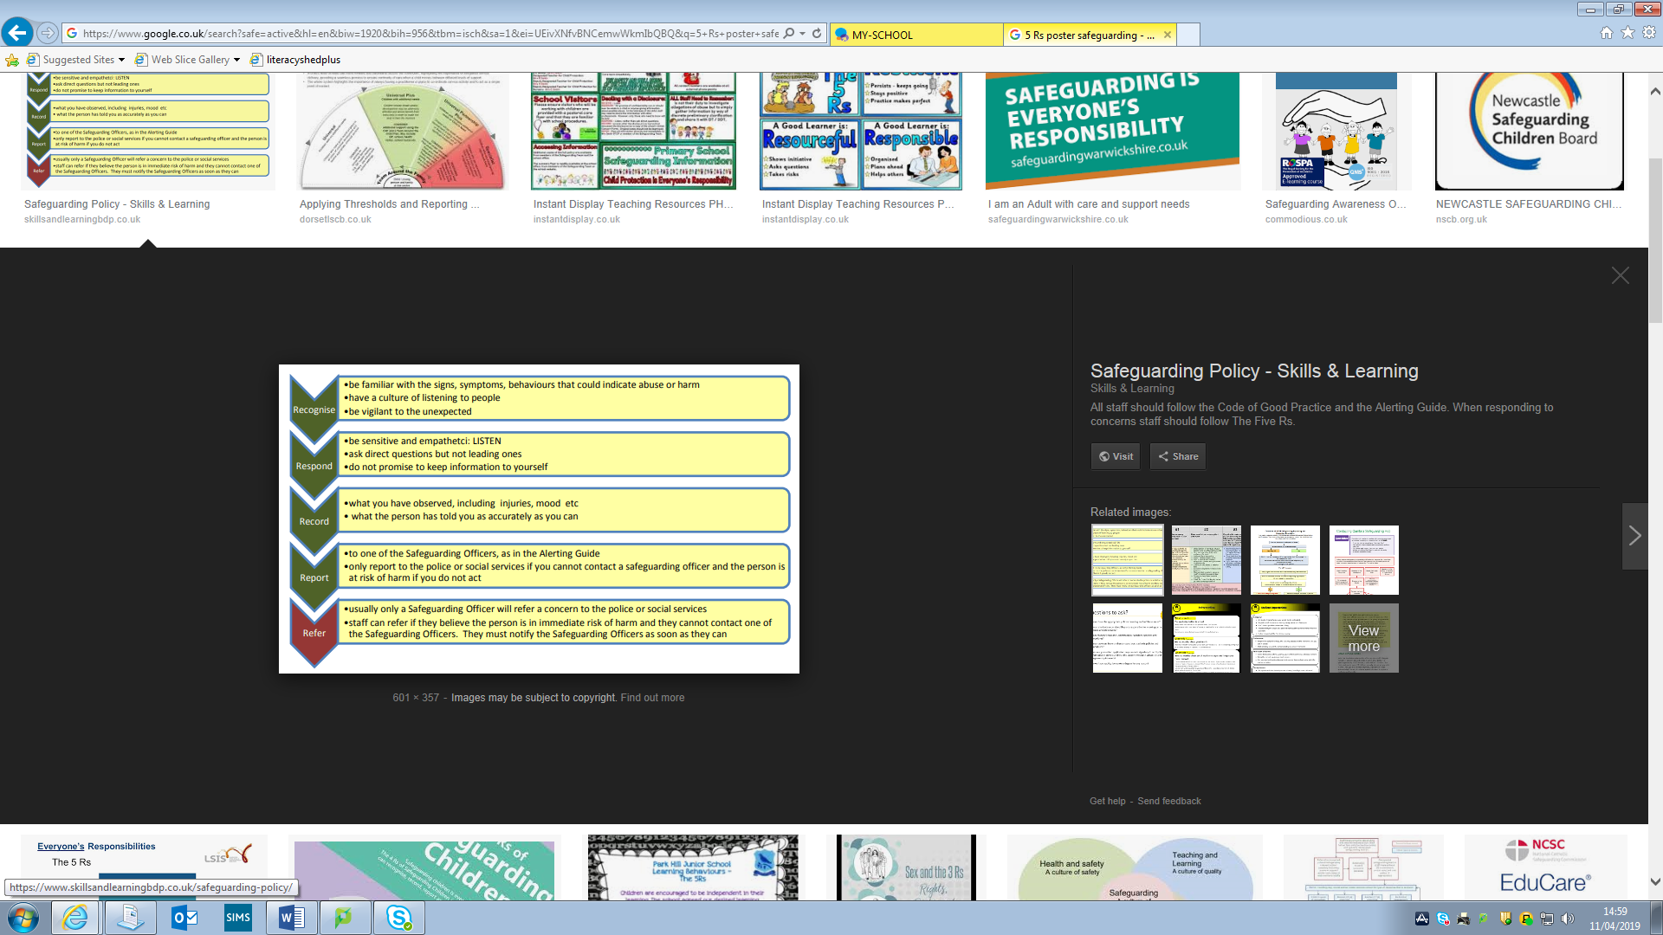

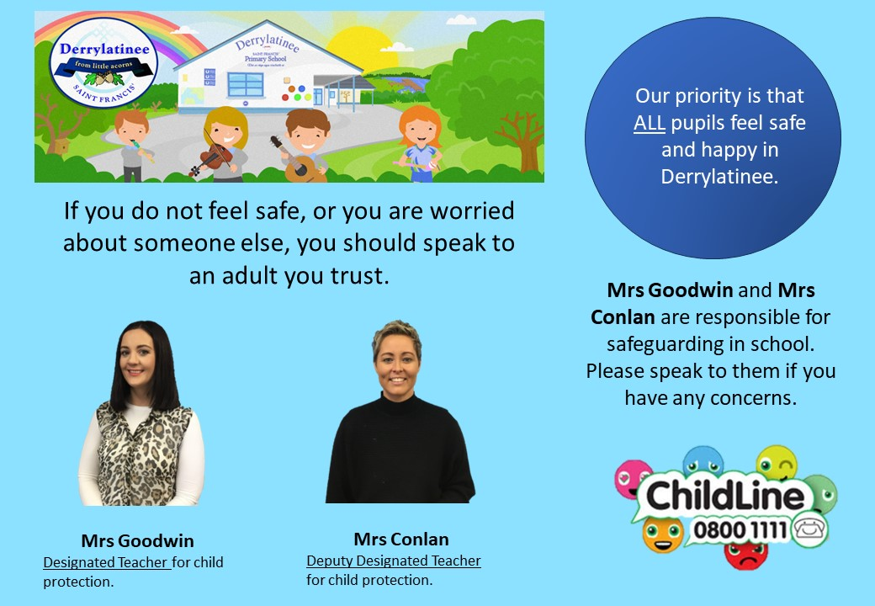
14.9 Appendix 9 – Safeguarding Team Posters

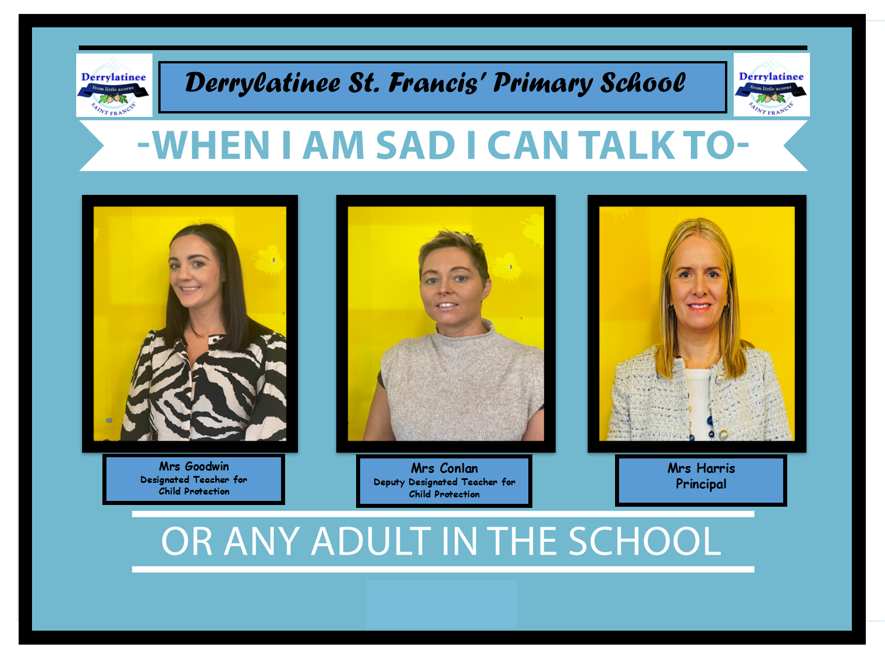

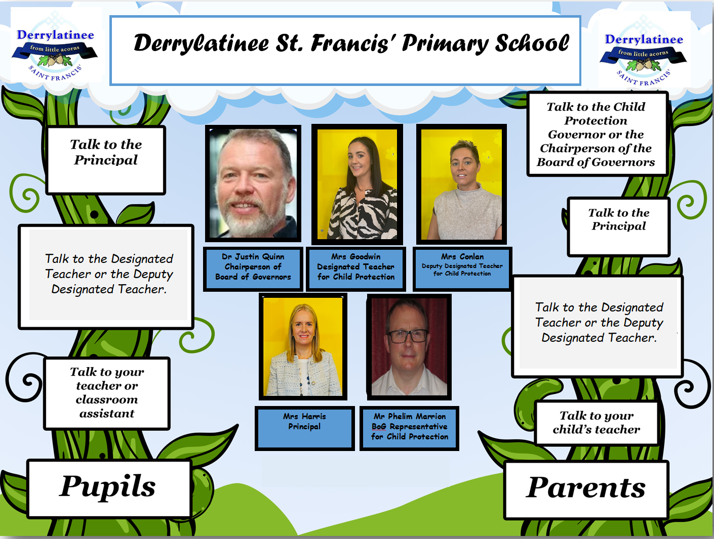

14.10 Appendix 10 – Useful Contacts

A social worker at the Gateway Team (Southern Trust) Tel: 028 87713506

Or

PSNI Central Referral Unit Tel: 02890259299 (or 101 extension 30299)

Co-Operating to Safeguard Children and Young People in Northern Ireland (August 2017) https://www.health-ni.gov.uk/publications/co-operating-safeguard-children-and-young-people-northern-ireland

